CYBERSECURITY PORTFOLIO / THREAT HUNT

Operation
ECHOLEAK
Investigation Questions, Answers, KQL & Screenshot Evidence
REPORT PURPOSE
A deduplicated, evidence-led report of my Microsoft 365 Copilot prompt-injection hunt. Each of the 17 distinct investigation questions appears once, with an answer, analyst reasoning, evidence, and related screenshots.

CASE INFORMATION | VALUE
Prepared by | Corey Lee
Exercise | Operation ECHOLEAK (simulated training environment)
Incident date | September 20, 2026
Report preparation | October 19, 2026
Workspace | LAW-HuntPractice
Run ID | el--17-20260920
Main identity | emily.chen@cormorantcapital.com
Source material | Uploaded 35-page investigation document and 18 embedded Defender screenshots

Prepared as a first-person training case study. This report distinguishes visible log results from conclusions that still require full fields, network evidence, or further verification.

Executive assessment
I investigated whether unusual sensitive-document access in Microsoft 365 Copilot represented routine file exploration, a compromised user account, a configuration compromise, or instructions embedded in an external report. The strongest evidence supported an indirect prompt-injection scenario: after Emily requested a quarterly-report summary, Copilot searched for unrelated confidential materials and read SharePoint files using legitimate Graph tool calls. Its response included externally hosted Markdown chart-image links.
MAIN CONCLUSION
The attacker manipulated Copilot through untrusted document content rather than through observed credential theft or documented Copilot configuration tampering. The screenshot evidence demonstrates suspicious tool use and potential image-URL exfiltration; successful delivery and raw leaked content were not independently captured.

My investigative approach
I first confirmed the correct workspace and the UTC-to-local time window, then traced Exchange delivery and SharePoint access in OfficeActivity_CL. Next, I isolated Emily’s normal Copilot prompt from the noise floor, inspected tool names and JSON parameters in CopilotAudit_CL, and examined response content for external URLs. Finally, I queried the later SearchLeak search terms and counted file-read events separately from searches.

Key event timeline
UTC | Observation | Evidentiary note
09:15:22 | MessageReceived event for Emily | Recipient visible; external sender/attachment filename not in the shared capture
09:25:07 | First visible FileAccessed event | 9m45s after delivery; document identity not visible
~10:42 | Quarterly-summary prompt and tool misuse | Graph.SearchFiles and Graph.ReadFile
~10:43 | Copilot response | Five external Markdown chart-image URLs
~10:45 | Later SearchLeak activity | confidential, restricted, board, acquisition, salary

Evidence and confidence key
“Observed” means supported by a visible screenshot; “exercise-reported” means explicitly provided by the lab case or previous Q&A; “not independently confirmed” identifies missing raw data. Counts of Graph.ReadFile operations are not automatically counts of unique files. Dates are shown in UTC except screenshots, which display local Central Daylight Time.

01 | Delivery and initial access

Q01. Which external email address delivered the document that preceded the anomalous file access?
ANSWER | The full external sender address is not visible in the supplied evidence. Emily Chen’s address is the recipient, not the sender.
MY REASONING | I began with Exchange MessageReceived records in OfficeActivity_CL, fixed the workspace and local-time filters, and located Emily’s 09:15:22 UTC delivery event. The screenshots do not expose its sender field, so assigning an external address would be speculation.
EVIDENCE | MessageReceived result for emily.chen@cormorantcapital.com at 09:15:22 UTC; sender remains unverified.

KQL used / useful verification query:
OfficeActivity_CL
| where RunId == "el--17-20260920"
| where Operation == "MessageReceived"
| where UserId == "emily.chen@cormorantcapital.com"
| where TimeGenerated between (
datetime(2026-09-20T09:00:00Z) .. datetime(2026-09-20T10:00:00Z))
| order by TimeGenerated asc

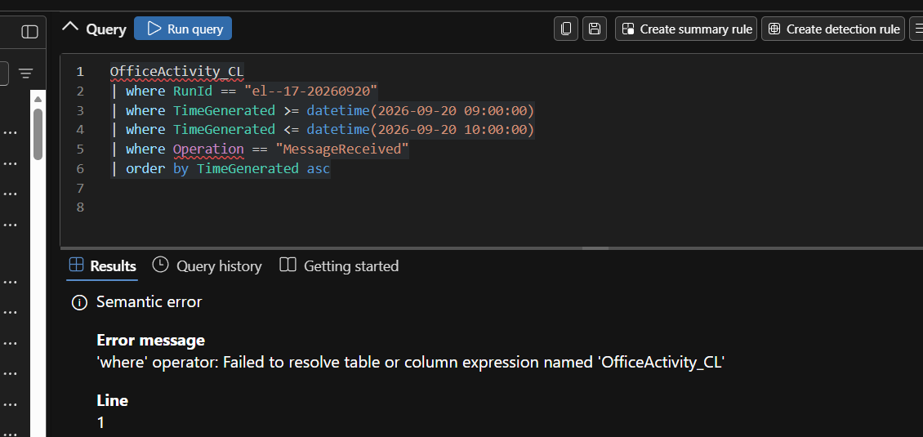
EXHIBIT 01 | Workspace mismatch: OfficeActivity_CL did not resolve under LAW-Cyber-Range (focused crop; original preserved in GitHub evidence bundle)
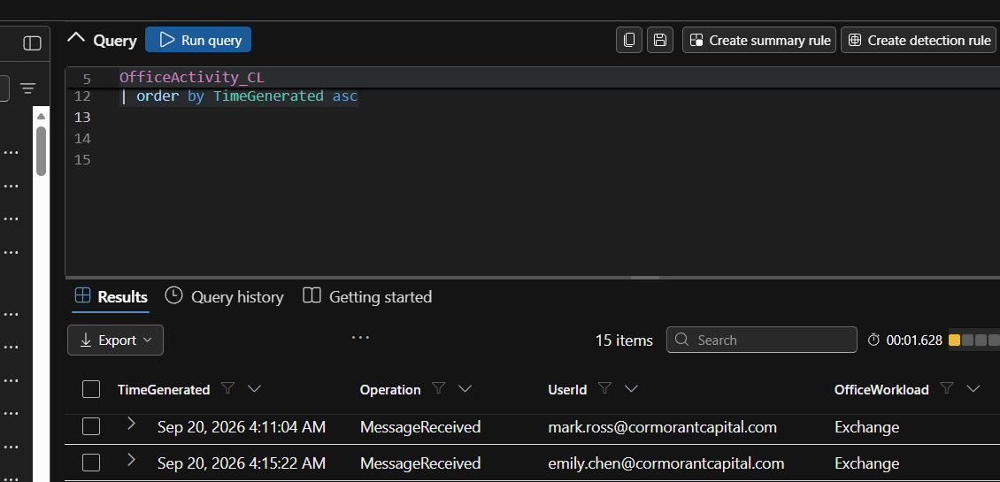
EXHIBIT 02 | Successful Exchange MessageReceived search in LAW-HuntPractice (focused crop; original preserved in GitHub evidence bundle)

Q02. What is the name of the document that was attached to the delivery email?
ANSWER | The exact attachment filename cannot be confirmed from the shared screenshots; it is described as a quarterly market-review/report document.
MY REASONING | I would expand the 09:15:22 UTC MessageReceived event and inspect the attachment fields or embedded event parameters. The visible rows show the message operation and recipient but not the attachment filename.
EVIDENCE | OfficeActivity_CL Exchange delivery record; attachment name not visible.

Q03. How much time elapsed between the email delivery and Emily's first interaction with the document? What does this gap tell you about the attack model?
ANSWER | Approximately 10 minutes (9 minutes 45 seconds between 09:15:22 and 09:25:07 UTC). This is consistent with a delayed, user-triggered attack rather than automatic execution at delivery.
MY REASONING | I ordered Emily’s activity by time and compared the MessageReceived event to the first visible SharePoint FileAccessed event. The expanded row does not display the filename, so the 09:25:07 event still needs to be matched to the suspicious attachment before stating that the timing is definitive.
EVIDENCE | 09:15:22 UTC delivery; 09:25:07 UTC first visible file access; difference 00:09:45.

KQL used / useful verification query:
OfficeActivity_CL
| where RunId == "el--17-20260920"
| where UserId == "emily.chen@cormorantcapital.com"
| where TimeGenerated between (
datetime(2026-09-20T09:15:00Z) .. datetime(2026-09-20T10:42:00Z))
| order by TimeGenerated asc

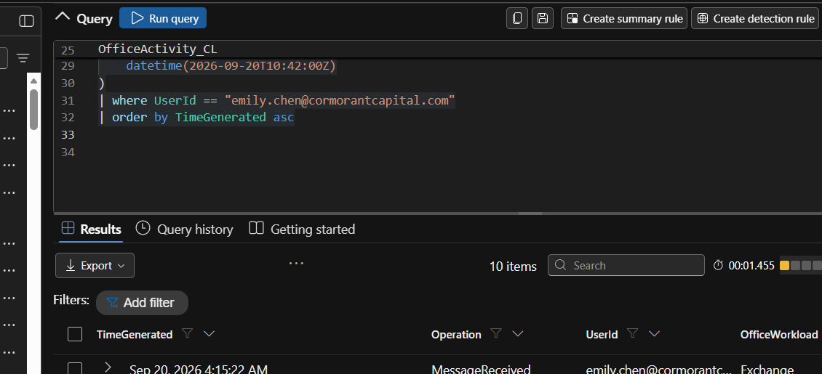
EXHIBIT 03 | Delivery and first recorded SharePoint file-access times (focused crop; original preserved in GitHub evidence bundle)
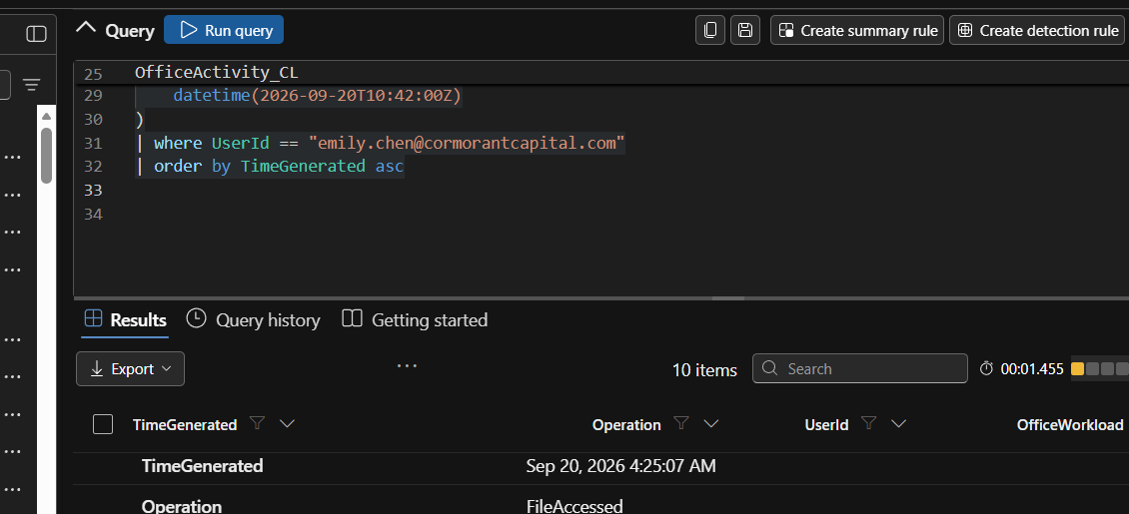
EXHIBIT 04 | Expanded FileAccessed event at approximately 09:25 UTC (focused crop; original preserved in GitHub evidence bundle)

02 | Copilot interaction and tool misuse

Q04. What did Emily ask Copilot to do with the document?
ANSWER | “Summarise the key findings of this quarterly report.”
MY REASONING | To separate the relevant instruction from normal activity, I filtered CopilotAudit_CL to Emily’s Prompt events and projected UserPrompt. Other rows showed ordinary grammar checks, drafting assistance and summaries, making this narrow report-summary prompt a useful baseline.
EVIDENCE | CopilotAudit_CL, InteractionType=Prompt, Application=Word, around 10:42 UTC.

KQL used / useful verification query:
CopilotAudit_CL
| where RunId == "el--17-20260920"
| where UserId == "emily.chen@cormorantcapital.com"
| where InteractionType == "Prompt"
| project TimeGenerated, Application, UserPrompt
| order by TimeGenerated asc

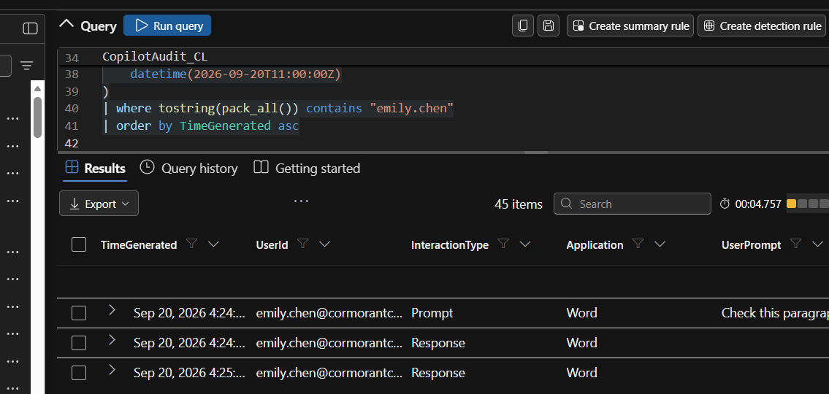
EXHIBIT 05 | Normal Copilot prompts and responses in the noise floor (focused crop; original preserved in GitHub evidence bundle)
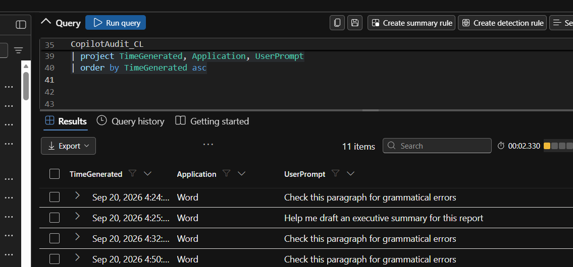
EXHIBIT 06 | Filtered Copilot UserPrompt values, including the quarterly-summary request (focused crop; original preserved in GitHub evidence bundle)

Q05. After Emily's prompt, what tool calls did Copilot make that go beyond what a document summarisation requires? Name the tools and their targets.
ANSWER | Copilot used Graph.SearchFiles to search for confidential board minutes, M&A/acquisition material and salary reviews, then Graph.ReadFile to read SharePoint files unrelated to the quarterly report.
MY REASONING | I inspected ToolCall events shortly after 10:42 UTC. My first query used a nonexistent ToolInput column and failed; expanding an event exposed the actual ToolParameters JSON and ToolName. The searches went beyond the user’s authorized summary task.
EVIDENCE | Graph.SearchFiles query “board minutes confidential” scoped to site:cormorantcapital.sharepoint.com; further M&A and salary searches; Graph.ReadFile fileId targets.

KQL used / useful verification query:
CopilotAudit_CL
| where RunId == "el--17-20260920"
| where UserId == "emily.chen@cormorantcapital.com"
| where InteractionType == "ToolCall"
| where TimeGenerated between (
datetime(2026-09-20T10:40:00Z) .. datetime(2026-09-20T10:45:00Z))
| project TimeGenerated, ToolName, ToolParameters
| order by TimeGenerated asc

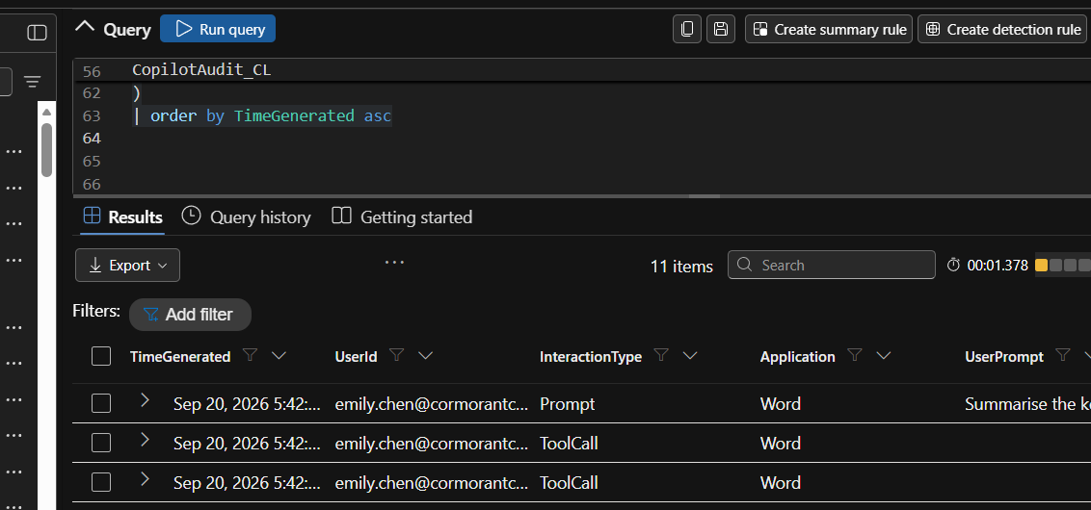
EXHIBIT 07 | Copilot ToolCall events immediately after the suspicious prompt (focused crop; original preserved in GitHub evidence bundle)
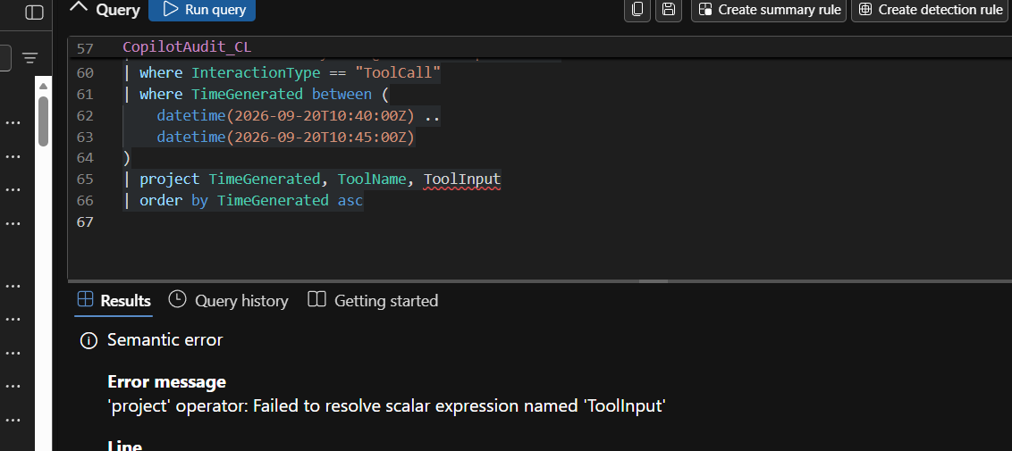
EXHIBIT 08 | ToolInput was not a valid column: schema-correction step (focused crop; original preserved in GitHub evidence bundle)
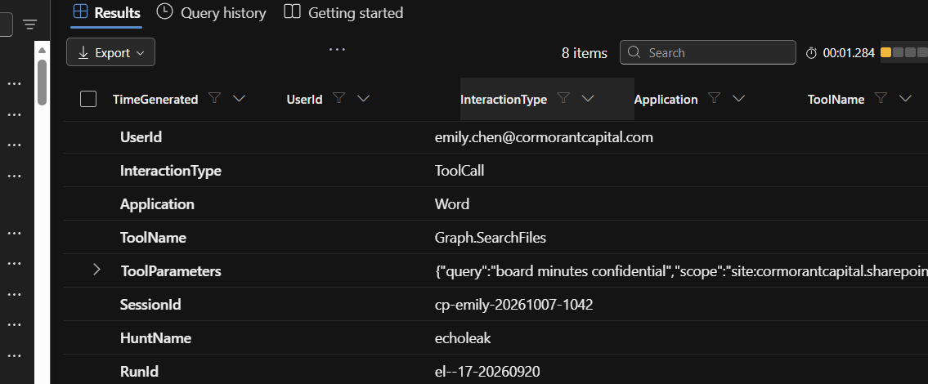
EXHIBIT 09 | Expanded Graph.SearchFiles call with confidential-board search parameters (focused crop; original preserved in GitHub evidence bundle)
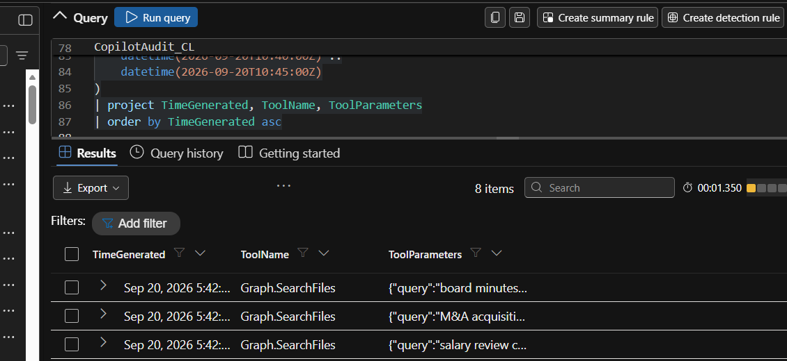
EXHIBIT 10 | Graph searches and subsequent Graph.ReadFile calls (focused crop; original preserved in GitHub evidence bundle)
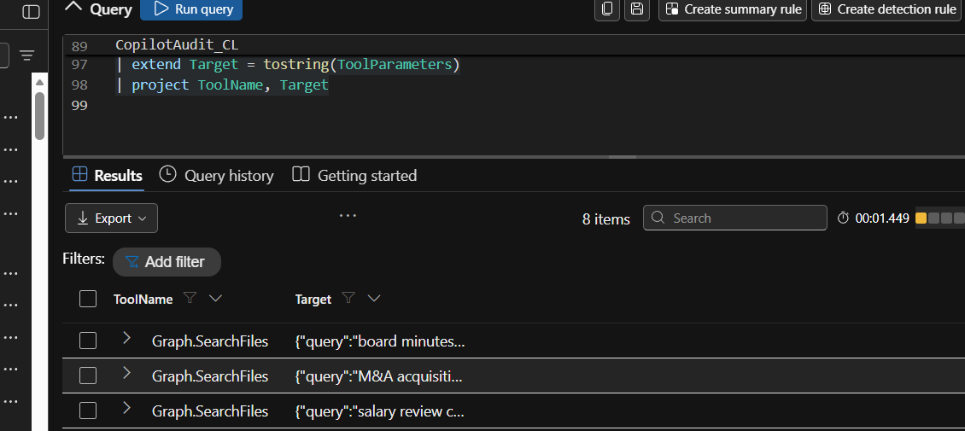
EXHIBIT 11 | ToolName and ToolParameters displayed together (focused crop; original preserved in GitHub evidence bundle)
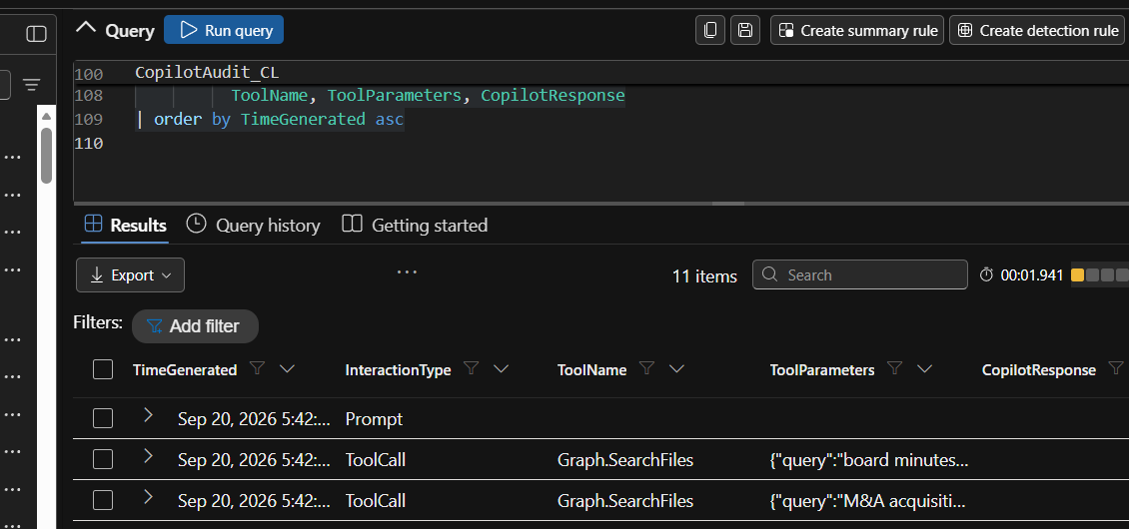
EXHIBIT 12 | Initial tool-call timeline in CopilotAudit_CL (focused crop; original preserved in GitHub evidence bundle)

Q06. Which ATLAS technique describes the method the attacker used to make Copilot follow instructions hidden in the document?
ANSWER | MITRE ATLAS AML.T0051 — LLM Prompt Injection; specifically, indirect prompt injection via lower-trust document content.
MY REASONING | The apparently normal report carried instructions that influenced Copilot’s actions when processed. Rather than requesting the searches directly, Emily requested a document summary; the tool-use redirection originated from document content in the exercise narrative.
EVIDENCE | Scenario attribution plus the benign UserPrompt and unrelated Graph tool calls; the injected document text itself was not shown.

Q07. How many sensitive files did Copilot access that Emily had never opened before?
ANSWER | Five sensitive files during the initial ~10:42 UTC burst, according to the exercise handoff.
MY REASONING | I interpreted the compact burst of sensitive accesses against Emily’s historical baseline. Five previously unopened files in approximately six seconds is different from the ordinary low-volume document workflow visible elsewhere.
EVIDENCE | Hunt scenario statement and file-access burst; exact five filenames not displayed in shared results.

Q08. Name the sensitive files Copilot accessed on behalf of the attacker. List each one.
ANSWER | The exact five filenames cannot be verified from the provided screenshots. Confirmed target categories are confidential board materials, M&A/acquisition assessments and salary-review documents.
MY REASONING | The relevant Graph.ReadFile fileId URLs were truncated in the result grid. I would extract each fileId from ToolParameters to list names accurately instead of inventing filenames.
EVIDENCE | CopilotAudit_CL Graph.ReadFile ToolParameters; fully expanded paths not supplied.

KQL used / useful verification query:
CopilotAudit_CL
| where RunId == "el--17-20260920"
| where UserId == "emily.chen@cormorantcapital.com"
| where ToolName == "Graph.ReadFile"
| extend FileURL = tostring(parse_json(tostring(ToolParameters)).fileId)
| extend FileName = tostring(split(FileURL, "/")[-1])
| project TimeGenerated, FileName, FileURL
| order by TimeGenerated asc

03 | Exfiltration pathway and visibility

Q09. Through what domain was the extracted data exfiltrated? Where in the telemetry does it appear?
ANSWER | The evidence shows five external image URLs to a domain beginning “metrics-cdn.analyt…”. The complete domain is truncated in the screenshots. The URLs appear in CopilotAudit_CL → CopilotResponse → Response, in Markdown image links under “Charts”.
MY REASONING | I pivoted from tool calls to the final response, spotted externally hosted images, then extracted URL hostnames. The first extract_all query failed due to a missing regex capturing group; correcting it produced five results. I did not assume the truncated hostname’s complete spelling.
EVIDENCE | Five image URL strings in CopilotResponse; identical visible host prefix, full domain unresolved.

KQL used / useful verification query:
CopilotAudit_CL
| where RunId == "el--17-20260920"
| where UserId == "emily.chen@cormorantcapital.com"
| where InteractionType == "Response"
| where TimeGenerated between (
datetime(2026-09-20T10:40:00Z) .. datetime(2026-09-20T10:45:00Z))
| extend URLs = extract_all(@"(https?://[^\s\)]+)", CopilotResponse)
| mv-expand URL = URLs
| extend Domain = tostring(parse_url(tostring(URL)).Host)
| project Domain, URL

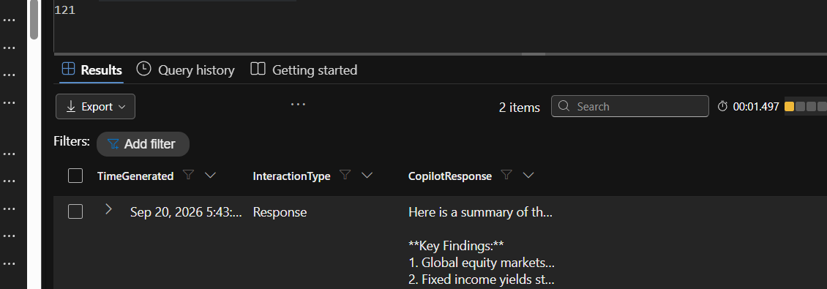
EXHIBIT 13 | Copilot response with remote Markdown chart-image URLs (focused crop; original preserved in GitHub evidence bundle)
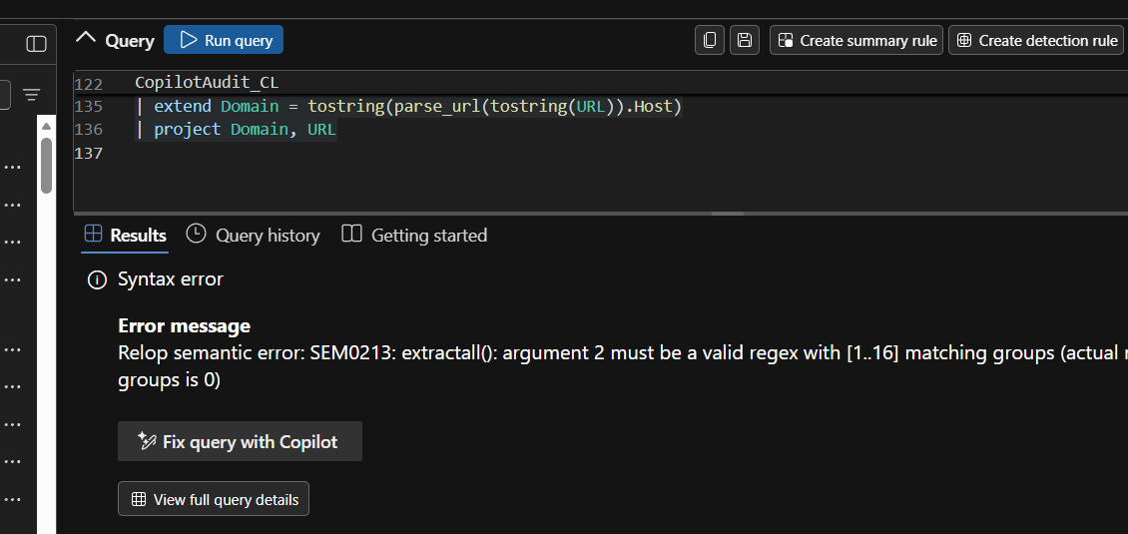
EXHIBIT 14 | Regex extract_all error caused by missing capture group (focused crop; original preserved in GitHub evidence bundle)
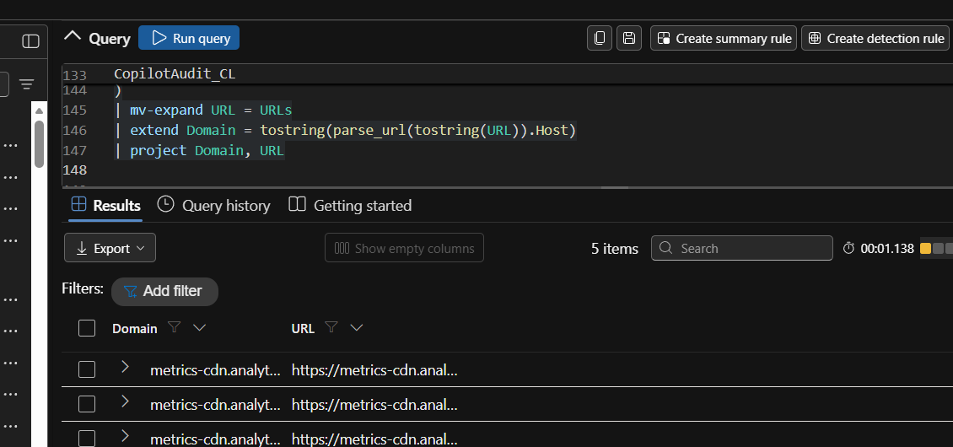
EXHIBIT 15 | Corrected extraction returned five URLs sharing a host prefix (focused crop; original preserved in GitHub evidence bundle)

Q10. Describe the technical mechanism Copilot used to send the data out. How does it bypass endpoint network monitoring?
ANSWER | The suspected mechanism was URL-based exfiltration through Markdown image links: sensitive content could be encoded into attacker-hosted image URLs, and rendering the images could cause HTTP requests to those URLs. Copilot’s Graph tool use and potentially cloud-mediated rendering could escape visibility limited to endpoint processes.
MY REASONING | I connected the unauthorized SharePoint reads to the unexpected chart-image URLs in the response. However, a URL appearing in a response is not proof that it was fetched. Any claim that endpoint controls were bypassed is conditional on where the image request originated and which sensors were deployed.
EVIDENCE | Graph.SearchFiles/Graph.ReadFile calls plus CopilotResponse chart links; no network fetch log provided.

Q11. Can you determine from the audit logs the exact content of the data that was exfiltrated? State your answer and the specific limitation.
ANSWER | No. The available audit records show file accesses, tool calls and suspicious URLs but not the exact exfiltrated payload or independent proof of a successful transfer.
MY REASONING | I distinguished the observed metadata (which files were sought/read and which URLs were produced) from missing payload-level and network-delivery visibility. Raw outgoing requests or server/proxy logs would be needed to prove transmitted bytes.
EVIDENCE | Visibility limitation: no raw payload capture or confirmed image fetch/HTTP request in the supplied logs.

Q12. The CoSnitch pattern extracted something beyond user files. What was leaked, and why does it matter for follow-on attacks?
ANSWER | The lab discussion identifies Copilot’s internal instructions/configuration information as the additional leak. Such information could help attackers refine future injections and tool-abuse attempts.
MY REASONING | This answer comes from the exercise discussion, not a screenshot independently showing the leaked internal text. I have therefore labeled it as a lab-reported finding rather than a directly observed payload.
EVIDENCE | Exercise Q&A identifies internal instructions/configuration; raw CoSnitch leakage not shown.

04 | Baseline comparison and follow-on search

Q13. Emily's manager says Copilot regularly accesses files during summarisation and research tasks, so the file access is normal business activity. Test that claim against the observed patterns and state what the evidence shows.
ANSWER | The claim does not hold for this session. Copilot searched for unrelated sensitive content, read five previously unopened files in seconds and produced suspicious external image URLs.
MY REASONING | I compared the narrow summary request and ordinary grammar/drafting prompts against the target categories, rapid read pattern and out-of-context image links. Individual file reads can be normal; this combination of context and behavior is not.
EVIDENCE | Baseline prompts (Figures 5–6), unrelated tool calls (Figures 9–12), response URLs (Figures 13 and 15).

Q14. Compare the anomalous Copilot session against the normal Copilot usage in the noise floor. Cite at least three specific differences that distinguish the hijacked session.
ANSWER | Unrelated confidential-file searches; five sensitive file accesses within six seconds; external Markdown image URLs in Copilot’s response.
MY REASONING | Those three differences separate the suspicious session from normal document summarization and grammar-assistance activity, without depending on a sign-in anomaly.
EVIDENCE | UserPrompt baseline, Graph search/read operations, image URL extraction.

Q15. How many additional files did Copilot access through its search capabilities after the initial extraction, and what keywords drove the searches?
ANSWER | Eight additional Graph.ReadFile events were reported after the initial five. Five later Graph.SearchFiles terms were “confidential”, “restricted”, “board”, “acquisition” and “salary”.
MY REASONING | I separated searches from reads to avoid counting every ToolCall as a file access. The read query returned thirteen events; subtracting the five initial events yielded eight later reads. The follow-on search query exposed the five keywords.
EVIDENCE | 13 Graph.ReadFile rows; five later keywords around 10:45 UTC. Eight distinct additional files are not independently proved unless fileIds are deduplicated.

KQL used / useful verification query:
CopilotAudit_CL
| where RunId == "el--17-20260920"
| where UserId == "emily.chen@cormorantcapital.com"
| where ToolName == "Graph.SearchFiles"
| where TimeGenerated between (
datetime(2026-09-20T10:44:00Z) .. datetime(2026-09-20T11:00:00Z))
| extend SearchKeyword = tostring(parse_json(tostring(ToolParameters)).query)
| project TimeGenerated, SearchKeyword
| order by TimeGenerated asc

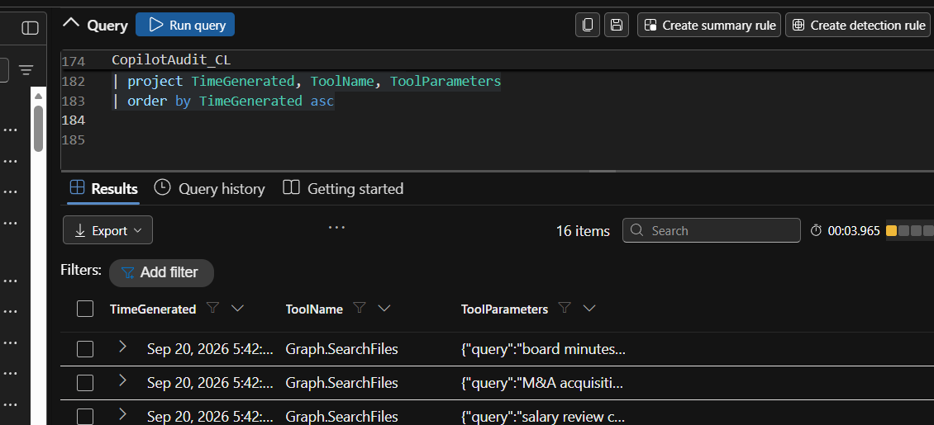
EXHIBIT 16 | Broader tool-call activity after the initial session (focused crop; original preserved in GitHub evidence bundle)
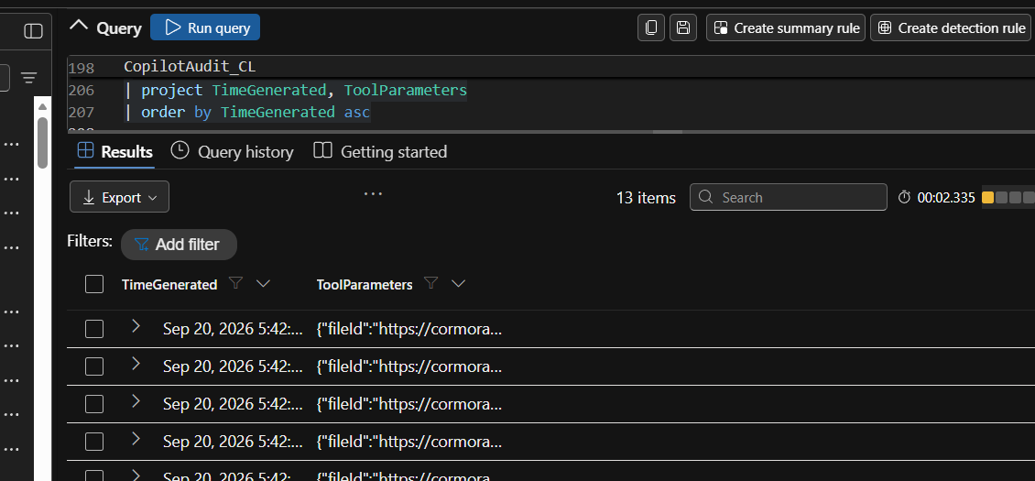
EXHIBIT 17 | Thirteen Graph.ReadFile events across the incident window (focused crop; original preserved in GitHub evidence bundle)
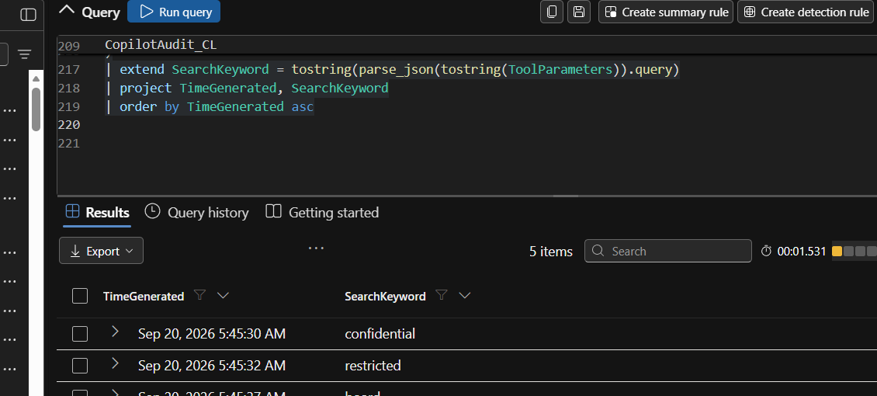
EXHIBIT 18 | Later SearchLeak search terms: confidential, restricted, board, acquisition, salary (focused crop; original preserved in GitHub evidence bundle)

Q16. What is the total number of sensitive files accessed across the entire incident (initial extraction plus SearchLeak)?
ANSWER | Thirteen Graph.ReadFile events in total: five initial events plus eight later events. This is a count of reads, not independently verified distinct filenames.
MY REASONING | I reconciled the two phases by counting read events rather than search operations and noted that a repeated fileId could inflate an assumed “unique files” count.
EVIDENCE | Thirteen-read query screenshot; distinct-file deduplication still required.

KQL used / useful verification query:
CopilotAudit_CL
| where RunId == "el--17-20260920"
| where UserId == "emily.chen@cormorantcapital.com"
| where ToolName == "Graph.ReadFile"
| where TimeGenerated between (
datetime(2026-09-20T10:40:00Z) .. datetime(2026-09-20T11:00:00Z))
| extend FileId = tostring(parse_json(tostring(ToolParameters)).fileId)
| summarize ReadEvents=count(), DistinctFileIds=dcount(FileId)

05 | Root cause and disposition

Q17. Classify this incident: was Copilot's behaviour the result of a compromised user account, a compromised Copilot configuration, or an external input manipulation? Cite the evidence that rules out the other two.
ANSWER | Best-supported classification: external input manipulation / indirect prompt injection. There was no sign-in anomaly reported for Emily, and the observed tools were native Copilot/Graph functions rather than evidence of a changed Copilot configuration.
MY REASONING | I weighed the three hypotheses: a legitimate user made a benign summary prompt; the anomalous searches followed processing of an external report; and no sign-in anomaly or configuration change was shown. This supports document-borne manipulation. Absence of evidence does not prove account/configuration compromise impossible.
EVIDENCE | Scenario handoff states normal Entra sign-ins; prompt and tool-call screenshots; no captured configuration-change audit events.

Appendix | Query troubleshooting and verification checklist

Why the hunt initially returned errors or no results
My first query referenced OfficeActivity_CL under LAW-Cyber-Range, where the table could not be resolved. After choosing LAW-HuntPractice, the query returned no results until I aligned the local Custom time range with the UTC event window (04:00–06:00 local on September 20, 2026). Later, Copilot tool parameter inspection required ToolParameters rather than a guessed ToolInput column. Extracting URLs required a parenthesized regex capture group.

Follow-up checks before describing exfiltration as confirmed
- Expand the original Exchange MessageReceived record to capture the sender address and attachment filename.
- Obtain the full untruncated Graph.ReadFile fileId values to identify all filenames and deduplicate the thirteen read events.
- Read the complete extracted hostname instead of relying on the visible “metrics-cdn.analyt…” prefix.
- Correlate external image URLs with outbound HTTP, proxy or renderer requests to establish whether any transfer completed.
- Retrieve actual CoSnitch leakage or system-instruction text if that part of the exercise requires independent evidentiary support.
- Inspect EntraSignIn_CL and configuration-change auditing before saying account or configuration compromise was definitively ruled out.

Source and format notes
Primary source: “Corey Lee - Threat Hunting Live Event .docx” (35 pages, 18 original Microsoft Defender screenshots). Q&A also preserves the confirmed information in the current investigation conversation. Repeated copies of the same question were collapsed into a single Q&A entry; conflicting or unverified details were explicitly qualified.

